
- By ordering on the NHS App

- By completing our online form

- By dropping prescription requests in at reception, by email or post.

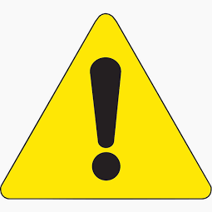
Important changes for
ordering your prescriptions
Community pharmacies and third parties will no longer be able to order medicines on your behalf*
This is to ensure safe and responsible issuing of medication and to prevent unnecessary medicines waste.
There are various ways in which you can order your regular medications for example:

Please note that your normal nominated pharmacy can continue to collect and deliver your prescription once issued by the doctor.
For further information please speak to a receptionist
or visit the practice website.

